AWS ADVANCED PROJECT-7

**DevOps-Jenkins-Installation and Configuration on Linux**

ARAVIND G KUMAR

**Introduction:**

**Jenkins** is a free and open-source automation server. It helps automate the parts of software development related to building, testing, and deploying, facilitating continuous integration and continuous delivery. It is a server-based system that runs in servlet containers such as Apache Tomcat.

* Create a Linux instance.
* Go to EC2 dashboard and click on create instance.
* Use the amazon Linux AMI and set everything to default.
* Launch the instance and connect it.

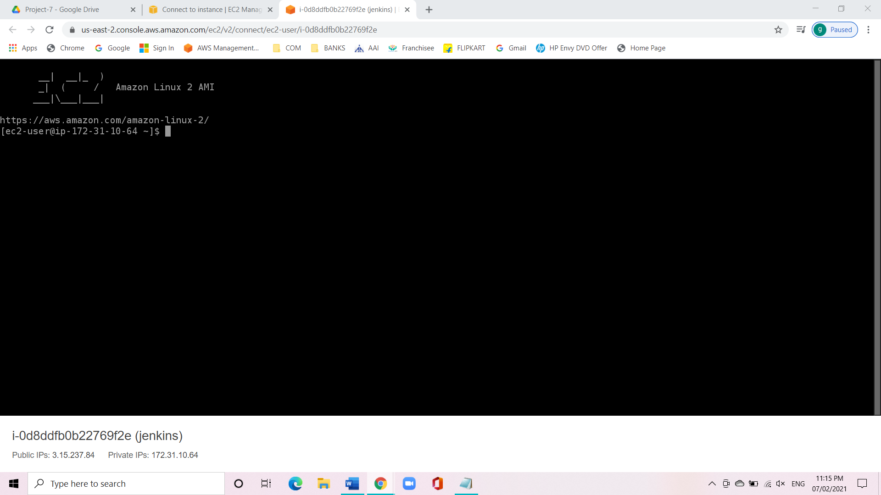

* Install java on Linux server.

Sudo su

Yum install java-1.8*

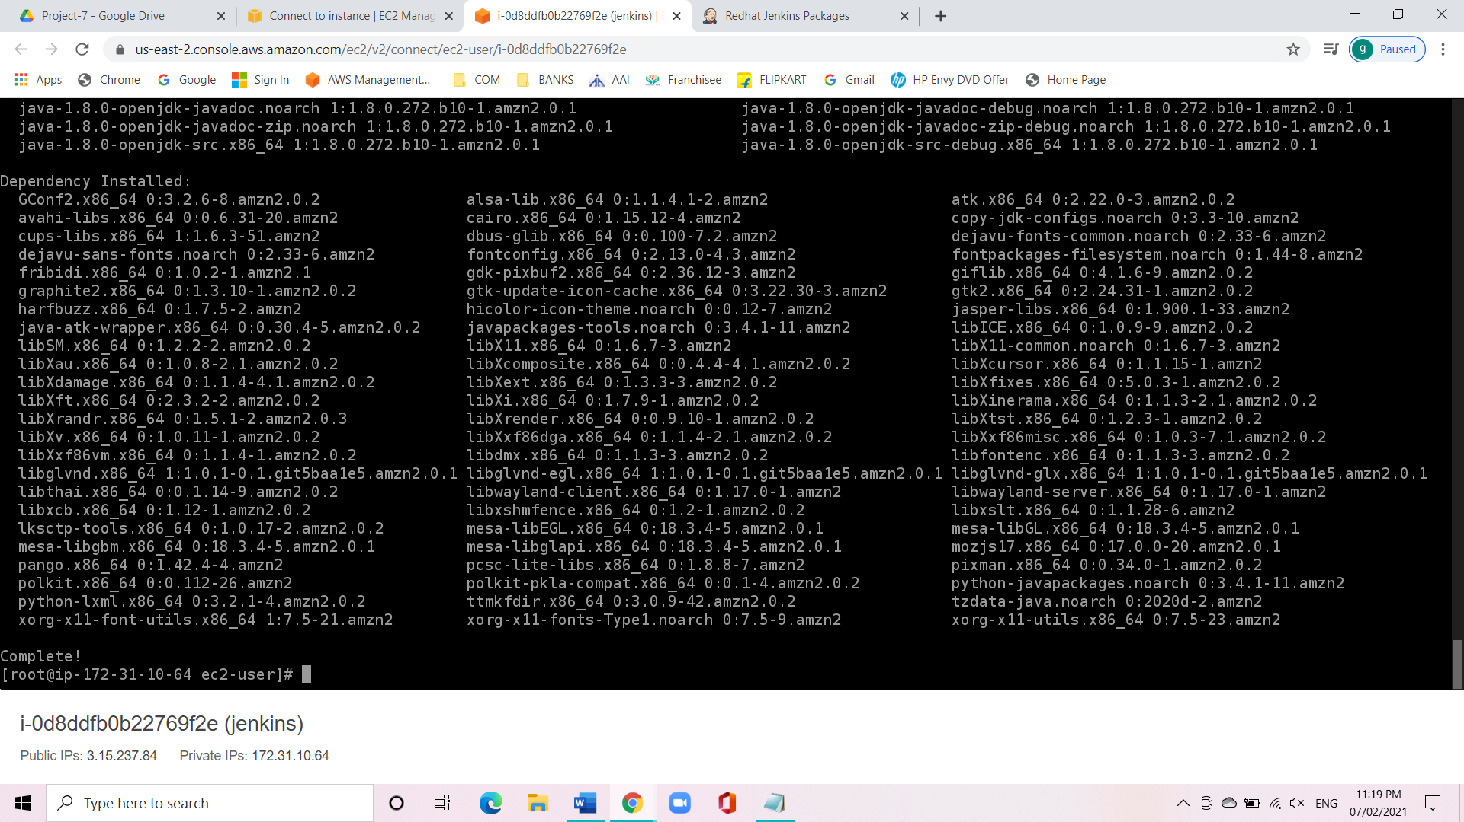

* Install Jenkins:

https://pkg.jenkins.io/redhat-stable/

sudo wget -O/etc/yum.repos.d/jenkins.repo

sudo rpm --import

yum install Jenkins

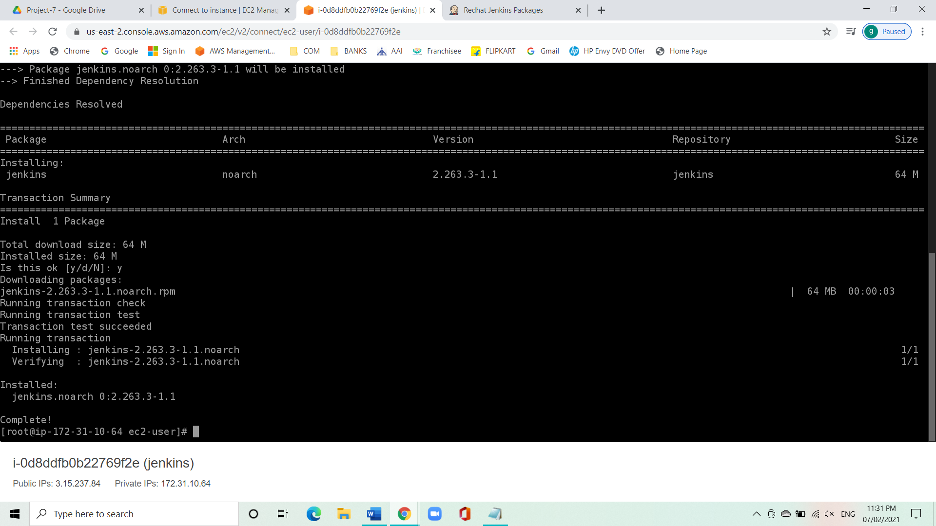

* Extract password from the location:
* Copy pastes the path from Jenkins.

Cat /var/lib/jenkins/secrets/initialAdminPassword

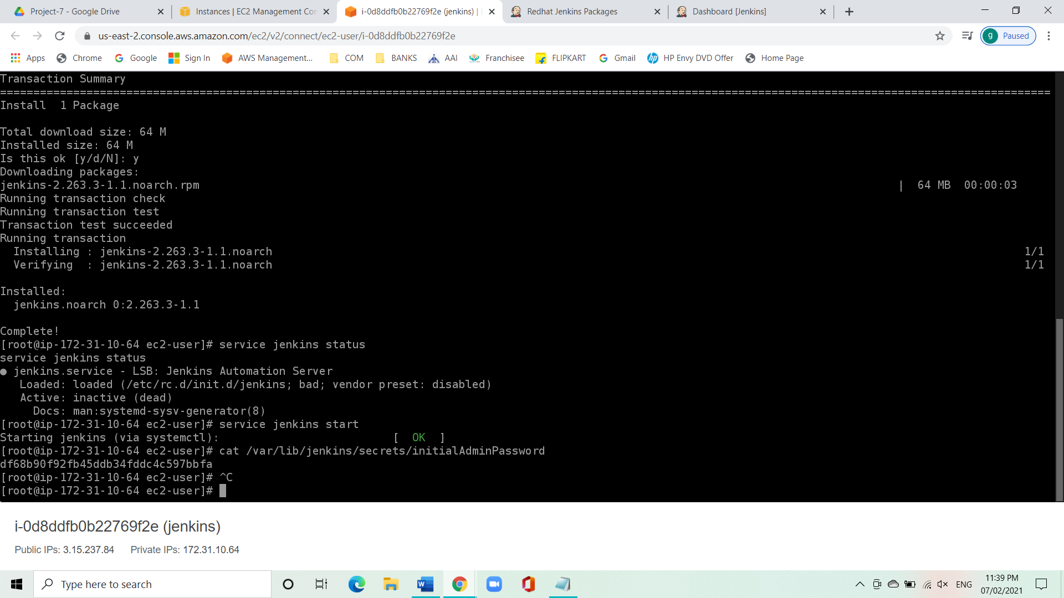

* Skip installing the plugins.
* Start Jenkins.
* Change the password.
* Create a new job.
* Click on new item.
* Enter the item name.
* Select free style project.
* Now scroll down and under build click on execute shell.
* Give the following command:

Echo “Wish you all good luck “

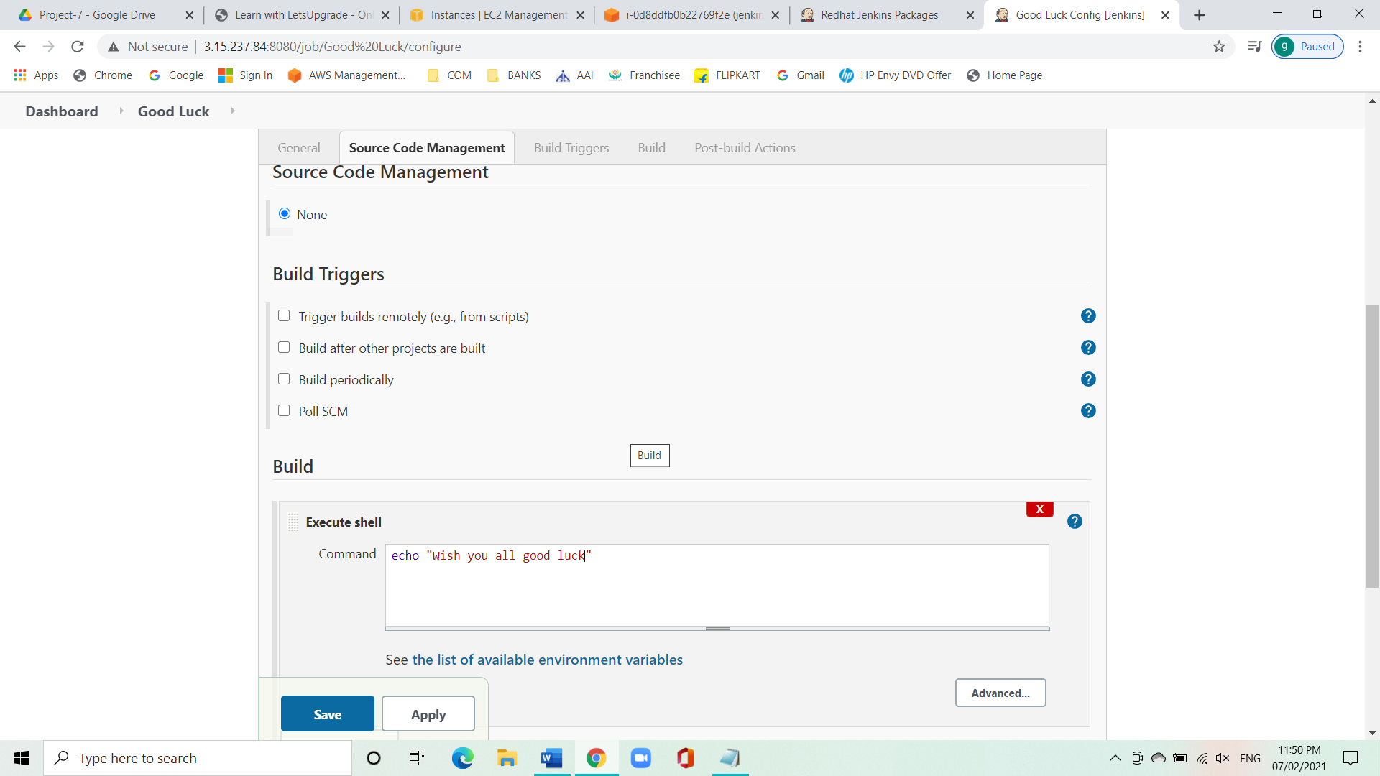

* Now click on apply and save.
* Click on build now.
* Click on console output to see the result.

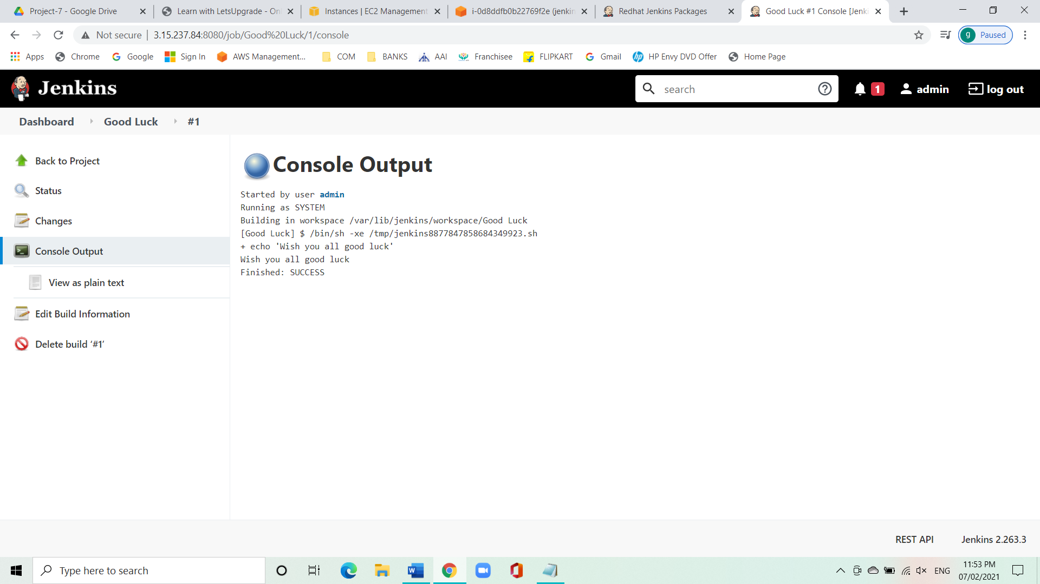

**Conclusion:**

We have successfully installed and configured Jenkins on Linux.